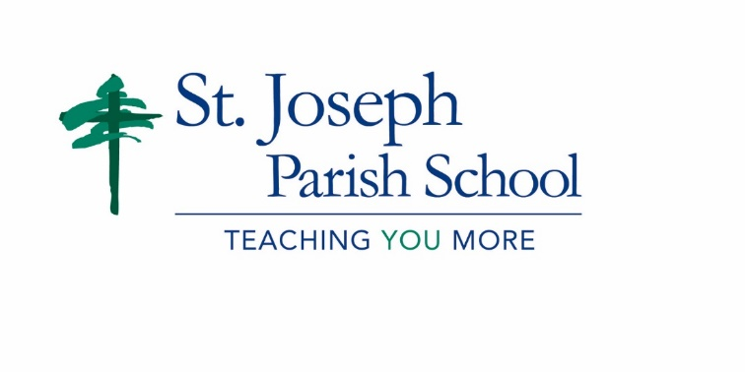
Competitive Speech Team- Winter 2018
Registration Form DUE to the Snoqualmie or Issaquah Office By Monday, December 4th!
NAME________________________________________________________AGE__________ GRADE_______________
PARENT/GUARDIAN EMAIL__________________________________________________________________________
HOME PHONE______________________________________________________________
PARENT/GUARDIAN CELL PHONE_______________________________________________
EMERGENCY CONTACT NAME: _________________________________________________
EMERGENCY CONTACT CELL PHONE: ____________________________________________
By registering for speech, I understand that I I will come to practices and I will be responsible for learning and practicing my speech material for the competition both at practice and outside of practice.

STUDENT SIGNATURE:_______________________________________________________________________________ DATE:________________

PARENT SIGNATURE:________________________________________________________________________________ DATE:________________

